Hayat Yayınları Tanıtım Bülteni
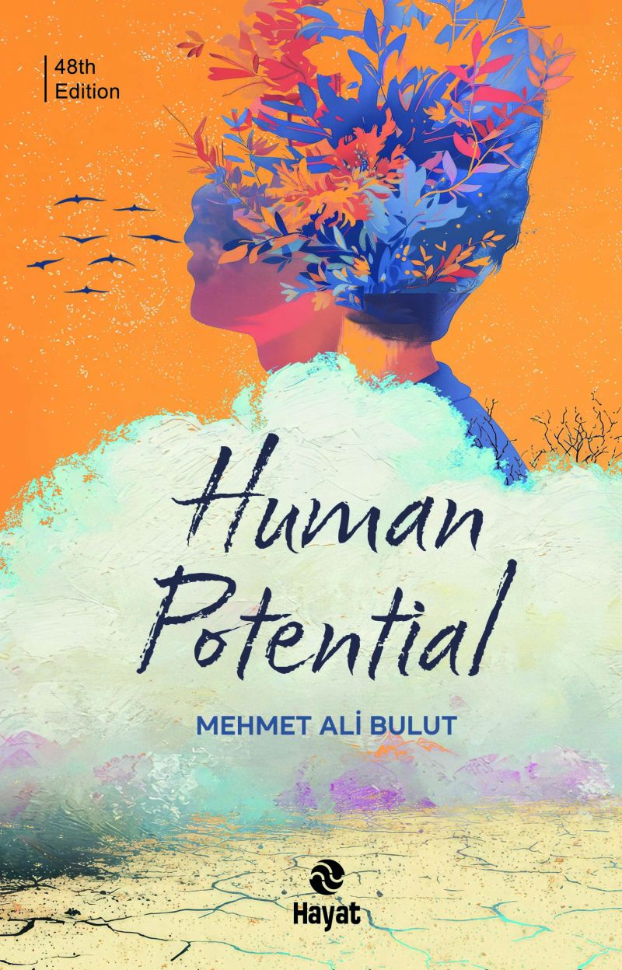 | Eser Adı: Human Potential  Yazar Adı: Mehmet Ali Bulut  Cilt Bilgisi:  Kitap Dili: İngilizce  Eser Tipi: Çeviri  İç Sayfa:  Kapak:  Yan Kapak: YOK  Selefon Türü:  Basım Tarihi: 2025  Sayfa Sayısı: 338  Kitap Boyutları: X  ISBN No: 9786051516257  Etiket Fiyatı: 600,00 TL  Mizanpajcı: Vildan Ekşi  Kapak Grafikeri: ENES MALİK KILIÇ  Çevirmen: Mehmet Özşahin  Son Kontrolcü: Hayati Bayrak
Kitap Tanıtım Yazısı : (Arka Kapak)

This book is a call to rise again.It is a disciplined exploration on the path to al-lnsan al-Kamil (the Perfect Human). Believing that our present human condition is no longer capable of building civiliza-tion, the author embarks on an attempt to reconstruct the kind of human being who can become a true builder of civilization. This work is also a study on.Jhe healthy nourishment of the mind. With this book. we will:

- break free from the prison of emotions that limit our abilities,

- discover the capacity and pqtential of our minds,

- explore our intellect, vast and boundless like an endless sea,

- and push the limits of oor memory and thought as we journey through the relationship between soul and body.

Kitabın detay sayfasına buradan ulaşabilirsiniz :
https://hayatyayinlari.com/kitaplar/mehmet-ali-bulut-ruhun-desifresi-2059.html
Hayat Yayınları



